REPORT

Introduction

This document describes the User Interface for the proposed Ashesi Health Center web application which is used solely to track patients’ details and history. The users of this application are the nurses at the Ashesi Health Center.

Structure and Navigation

The structure of the application is quite easy and simple to use. This is because it is expected that the nurse will be busy and would want to attend to as many patients as possible. Also, the nurses are transferred to other hospitals frequently and there is no time to train new nurses to use the application properly. Therefore, it is imperative that the user interface design is simple and not complicated for the nurse to understand. Further instructions are given to specific parts where the nurse may be new to the application.

In order to reduce the time spent navigating on the application to perform one function, mostly buttons and search boxes are implemented. Also there are quick links on the side bar that are useful to the nurse which will redirect to the page requested without requiring the nurse to type the URL into the search box.

Screen Description

The specific placement of the various interface components highlight the features of the software.

The header shows the user who is logged in at that particular time so as for the user to always know whether he/she is correctly logged in. The menu bar has all the functional requirements listed up there for easy access. The logout link is also located at the top left corner.

The title bar is placed above the content bars. This shows the specific function that is being carried out at the moment. In this case, the title is “View Patient’s records”.

There is also a side bar which contains quick links to the calendar, more information on the website, sending a mail and the dictionary. These links are considered important to the nurse.

There is also a search box to enable quick search of the patient’s records to reduce the time the nurse spends on the page.

Through these components, the non-functional requirements of usability and short response time. To reduce the time is takes to load the page, images were not used in the implementation of the design, and therefore, it takes less than one second for the page to load. Also simple shapes and colours were used to not confuse the nurse.

The user interface is intuitive because there are links named clearly by their specific functional requirements and as a result will be easy and natural for the nurse to operate. The format of the input required in any textbox is clearly stated to avoid confusion. Since the buttons are clearly stated in the medical terms, the user will be familiar with them.

It is important that users do not make mistakes as they are filling the patient’s information, therefore status messages will be highlighted. Unfilled textboxes would also be highlighted to give the user an idea of the missing information. Additional instructions would also come up. The colours chosen are green, silver and white. These colours are gender neutral and are cool which means that they give off a cool psychological effect which is instrumental in relaxing the nurse especially during hectic times.

Unfortunately, the case of different screen sizes and spaces was not properly addressed in the implementation. Also, there was no use for pop-ups for this specific functional requirement.

Conclusion

In order to reduce the time spent by the nurse to navigate the application, aesthetics is sacrificed for functionality in this specific User Interface design.

Screen shot:

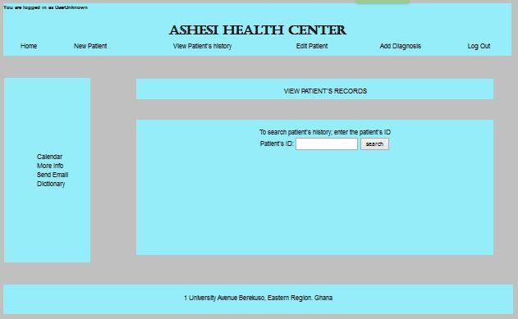

TIMESHEET

|  |  |  |
| --- | --- | --- |
| **DATE** | **NUMBER OF HOURS SPENT** | **WORK DONE** |
| 29th March | 3 | Designed the User Interface for my specific functional requirement |
| 30th March | 6 | Started implementing the user interface design in html and css |
| 31st March | 6 | Completed implementing the design and writing the report. |